# Latest topics in AI

* style transfer -> giving a Gogh potrait, it transforms any picture to van gogh style
* generative adversarial networks -> giving a real person photo, changing it to any kind of person.
* 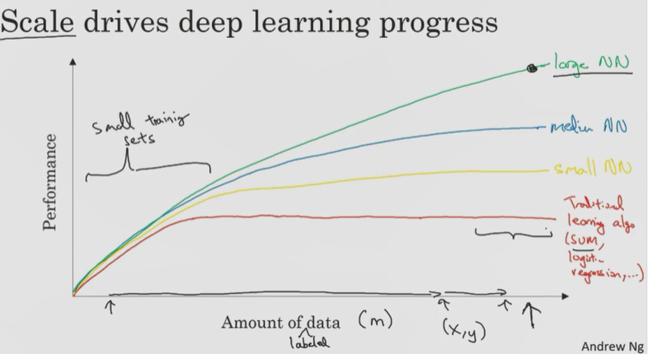
* <https://medium.com/the-theory-of-everything/understanding-activation-functions-in-neural-networks-9491262884e0>
* why do we have so many activation functions?”, “why is that one works better than the other?”, ”how do we know which one to use
* https://towardsdatascience.com/activation-functions-neural-networks-1cbd9f8d91d6

# Heroes of Deep Learning

## Geoffrey Hinton

* Lashley experiment
* Langer Higgins
* David Rumelhart

## Pieter Abbeel

deep learning has already transformed traditional internet businesses like web search and advertising.

But deep learning is also enabling brand new products and businesses and ways of helping people to be created

# W1

## Neural Network

## Deep Learning,

Refers to training Neural Networks, sometimes very large Neural Networks

## Neuron



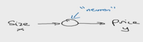

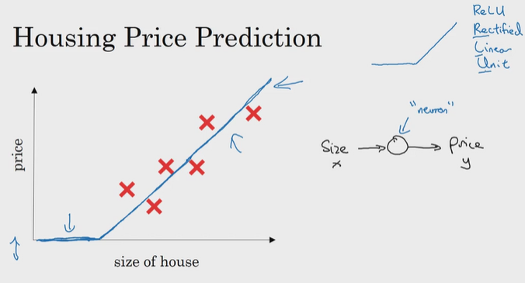

ReLU: Rectified Linear Unit

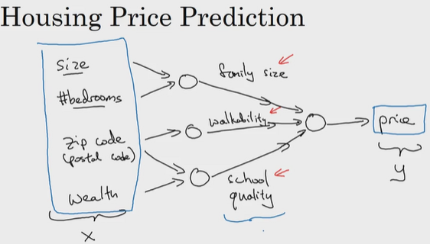

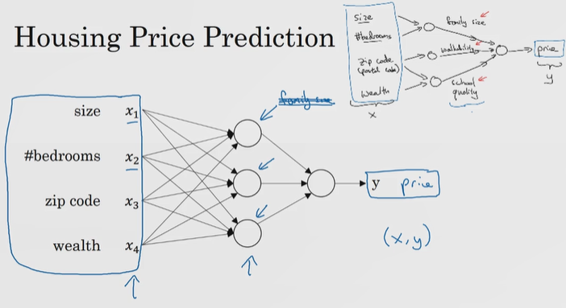

## Supervised L.withNN.

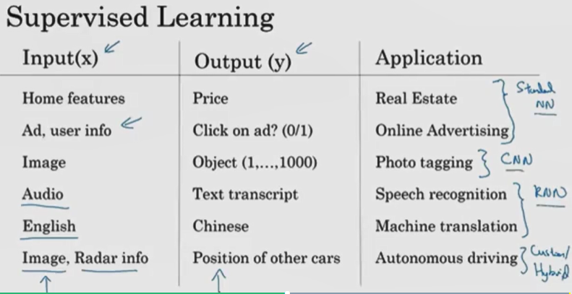

## NN Examples

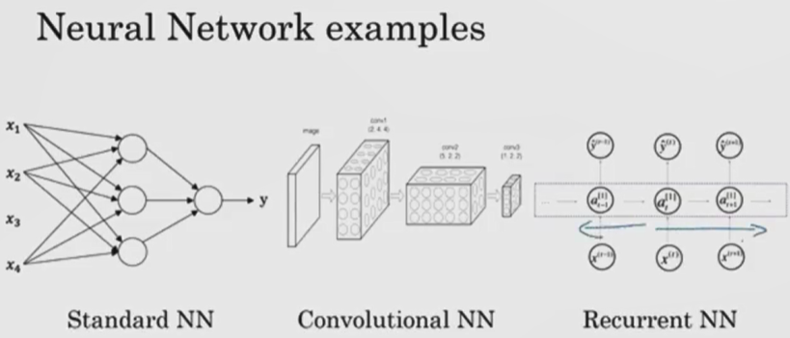

Convolutional- kıvrımlı büklümlü

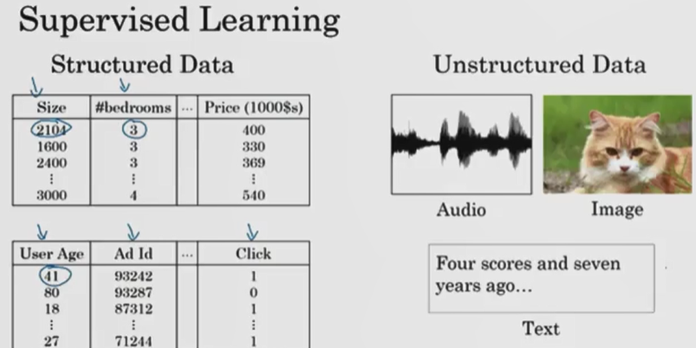



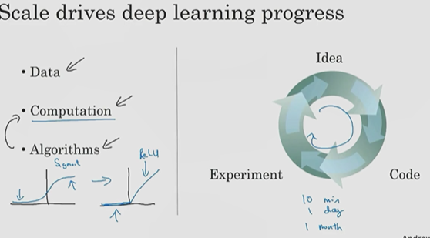

## Sigmoid:

* + problems of using sigmoid functions and machine learning is where the slope of the function would gradient is nearly zero and so learning becomes really slow because when you implement gradient descent and gradient is zero the parameters just change very slowly and so learning is very slow

## relu

* + The gradient is equal to one for all positive values of input right and so the gradient is much less likely to gradually shrink to zero and so it is faster.
* Python has several deep learning frameworks running on top of it (Tensorflow, Keras, PaddlePaddle, CNTK, Caffe, ...)

# W2

## Binary Classification

* If you have a training set of m training examples, you might be used to processing the training set by having a for loop step through your m training examples.
* When you're implementing a neural network, you usually want to process your entire training set without using an explicit for loop to loop over your entire training set.
* Another idea, when you organize the computation of, in your network, usually you have what's called a forward pause or forward propagation step, followed by a backward pause or what's called a backward propagation step
* Logistic regression is an algorithm for binary classification.

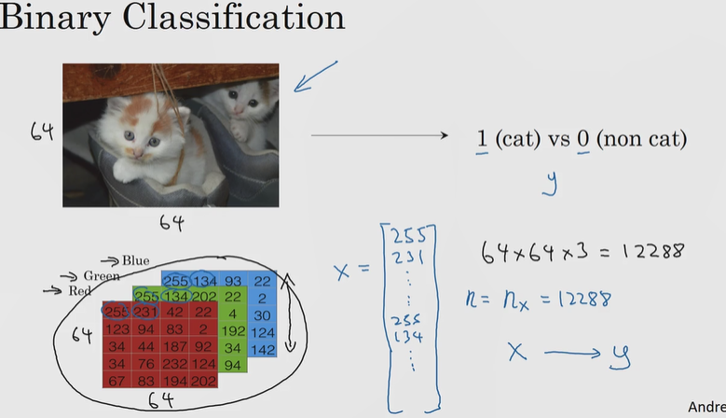

Unroll from 3(rgb)*64*64 matrix to a vector X =122288

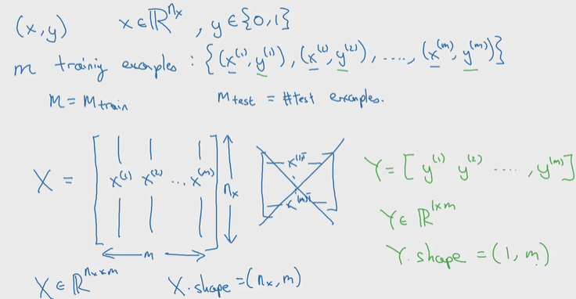

All m examples of x1 is gathered at the X big matrice.

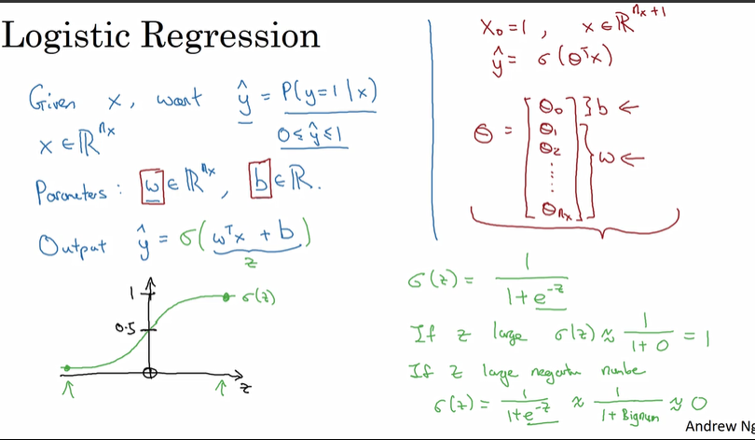

* All Y s are all 0 or 1.
* Y hat is probability of y=1
* **In order to get y between 0 and 1; sigmoid of(wT*x + b) -> sigmoid(z) is taken. Z= wt*x+b**
* If z is large number then g(z) is 1; else g(z) is 0
* 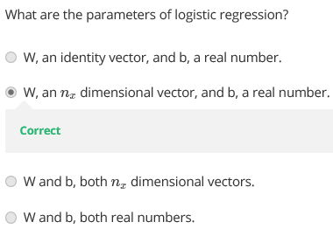

## Logistic R.Cost Function

* Logistic regression perform well when dataset is linearly seperable.
* To train the parameters W and B of the logistic regression model, you need to define a cost function.
* 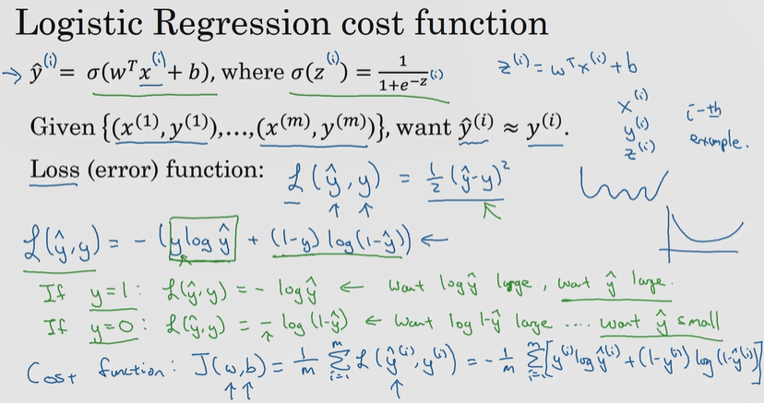
* As square error seems like it might be a reasonable choice except that it makes gradient descent not work well. (for square(yhat)- square(y )
* So in logistic regression, we will actually define a different loss function that plays a similar role as squared error, that will give us an optimization problem that is convex and so we'll see in that later video becomes much easier to optimize( logarithmic formulas above)

It turns out that logistic regression can be viewed as a very very small neural network

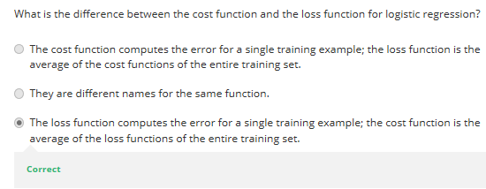

## Loss function

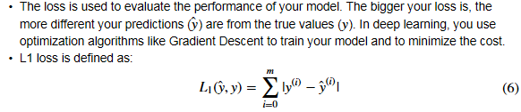

## Gradient Descent

* To find a good value for the parameters, what we'll do is **initialize w and b to some initial value**
* And for logistic regression almost any initialization method works, usually you initialize the value to zero.
* Random initialization also works, but people don't usually do that for logistic regression. But because this function is convex, no matter where you initialize, you should get to the same point or roughly the same point.
* And what gradient descent does is it starts at that initial point and then takes a step in the steepest downhill direction.
* So after one step of gradient descent you might end up there, because it's trying to take a step downhill in the direction of steepest descent or as quickly downhill as possible.

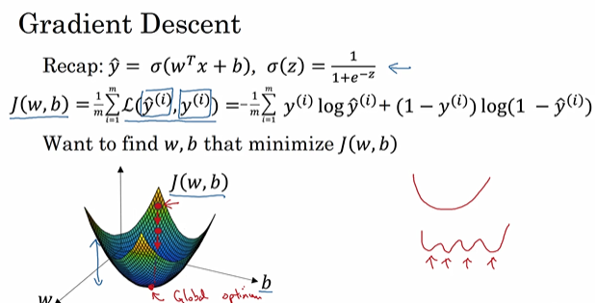

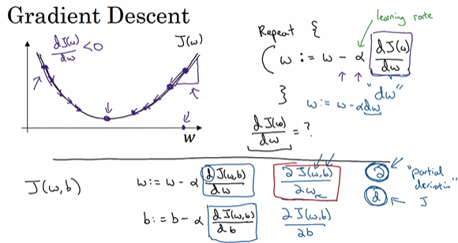

* you update b as b minus the learning rate times the derivative of the cost function in respect to b.

## +-Derivatives

* Height/width ratio
* Slope=derivative

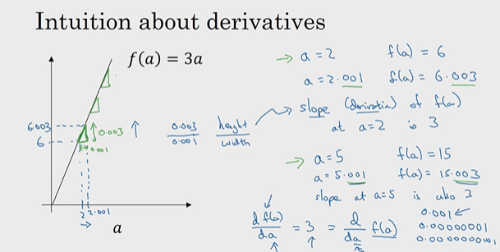

* In above example the derivative is constant (3)
* But in the below example it is parametric(2*a)

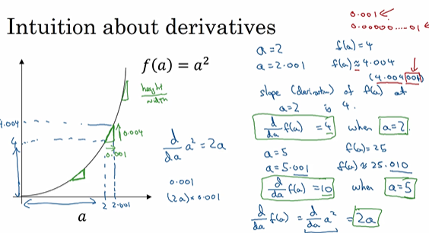

## Computation Graph

* computations of a neural network are organized in terms of a forward pass or a forward propagation step, in which we compute the output of the neural network,
* followed by a backward pass or back propagation step, which we use to compute gradients or compute derivatives
* The computation graph explains why it is organized this way

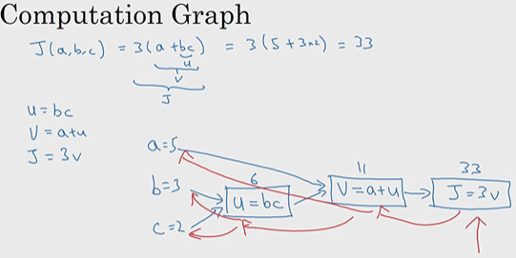

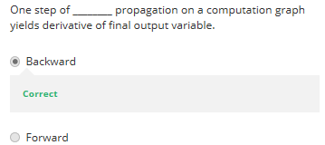

* 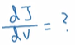 what does it mean?
* if we were to take this value of v and change it a little bit, how would the value of J change?

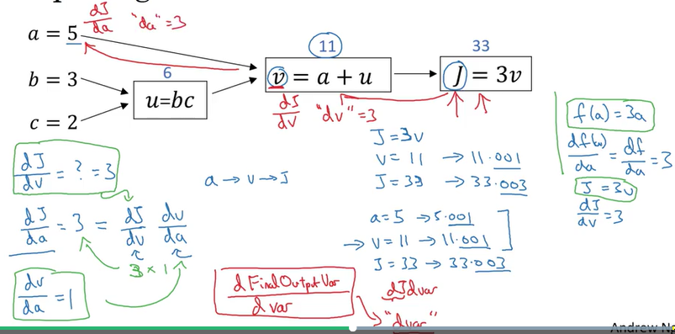

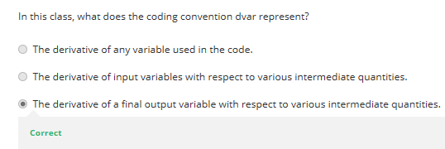

## Logistic Reg. GD

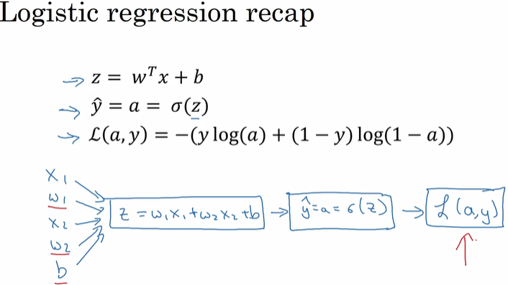

* In logistic regression, what we want to **do is to modify the parameters, W and B, in order to reduce this loss.**(one example cost)
* We've described the four propagation steps of how you actually compute the loss on a single training example,
* Now let's talk about how you can go backwards to compute the derivatives. Here's a cleaned-up version of the diagram

## Forward and backward propagation

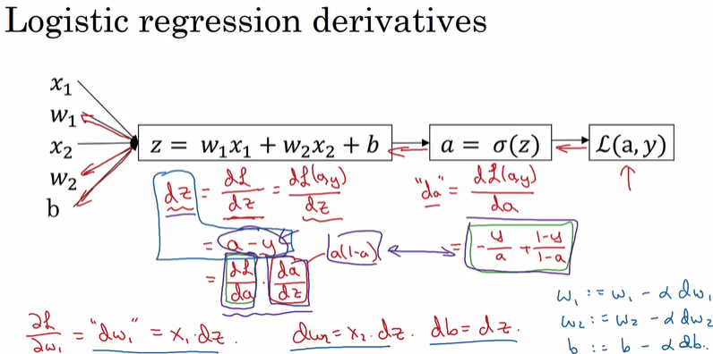

The final step in that computation is to go back to compute how much you need to change W and B.

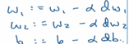

* W1 gets updated as W1 minus, learning rate alpha, times DW1
* And so, this will be one step of grade with respect to a single example.

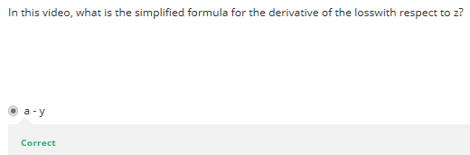

## GD on m Examples

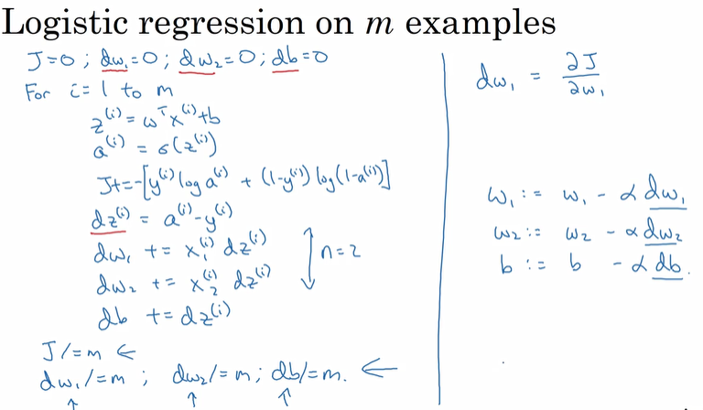

* there are two weaknesses with the calculation as with as with implemental adhere which is that to implement logistic regression this way you need to write two for loops
  + the first for loop is a small loop over the M training examples
  + the second for loop is a for loop over all the features(denoted as n)
* there are set of techniques called vectorization techniques that allows you to get rid of these explicit full loops in your code

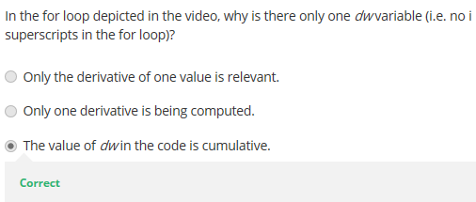

## Vectorization

* Vectorization is basically the art of getting rid of explicit for loops in your code,
* It provides computational efficiency and clarity.
* you often find yourself training on relatively large data sets, because that's when deep learning algorithms tend to shine
* And so, it's important that your code very quickly because otherwise, if it's running on a big data set, your code might take a long time to run then you just find yourself waiting a very long time to get the result

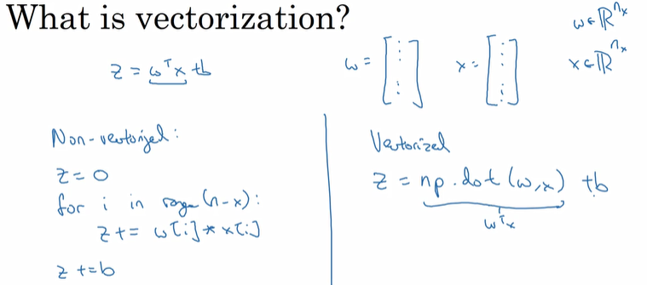

* Vectorized version versus looped version

Difference between vectorized and nonvec

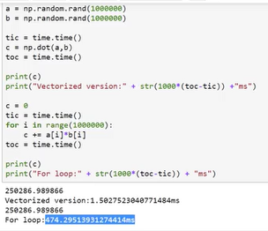

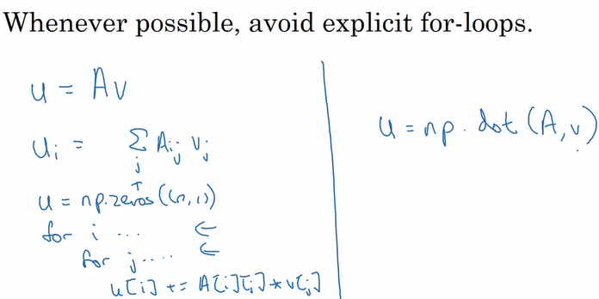

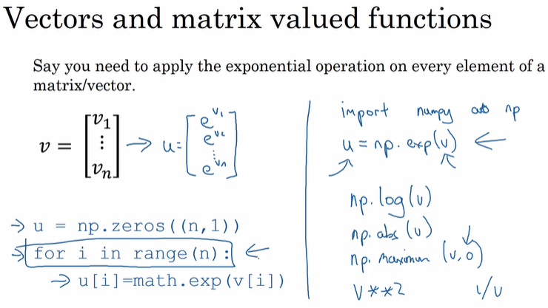

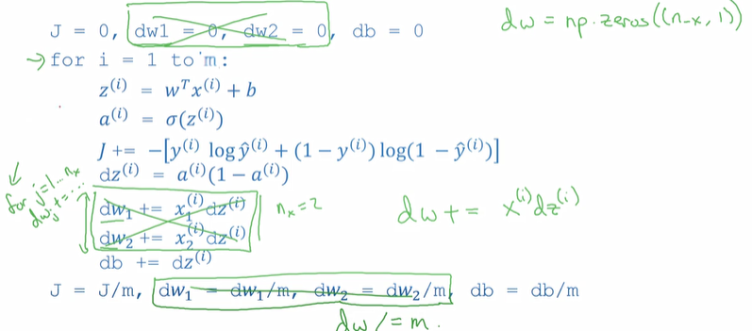

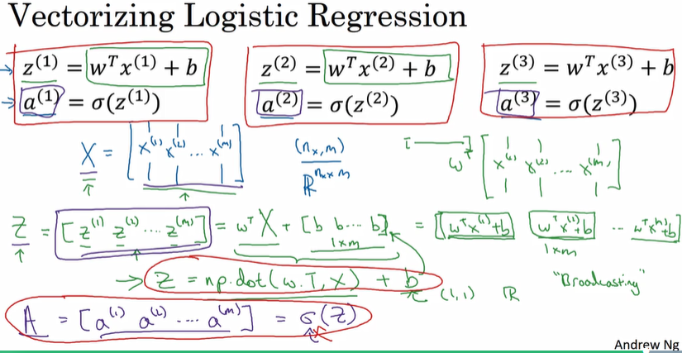

how you can use vectorization to also perform the gradient computations for all M training samples.

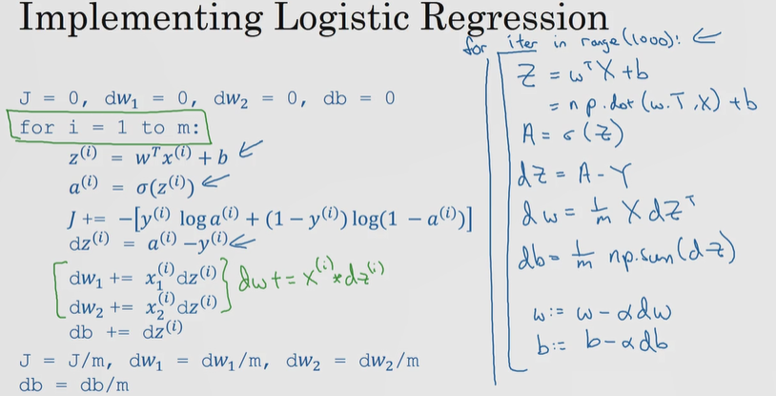

Vectorization is used to compute all of the activations, all the lowercase A's at the same time.

IT can also be used to compute the backward propagation, to compute the gradients.

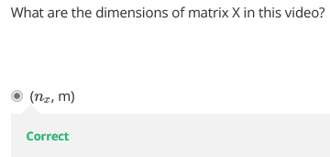

## Vectorizing Logistic Regression

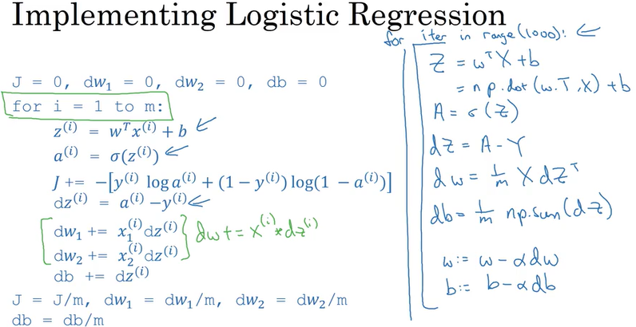

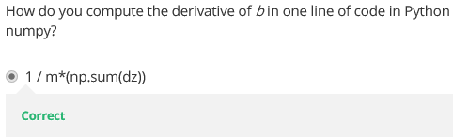

## Normalization

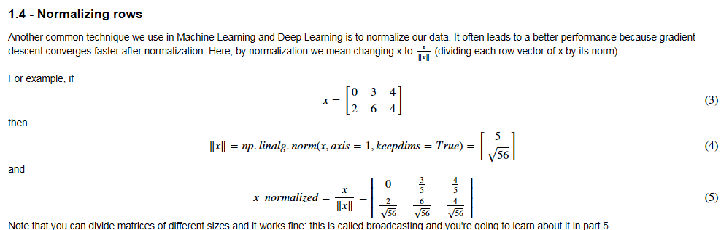

## Broadcasting in Phyton

* Broadcasting is another technique that you can use to make your Python code run faster
* It is very useful for performing mathematical operations between arrays of different shapes

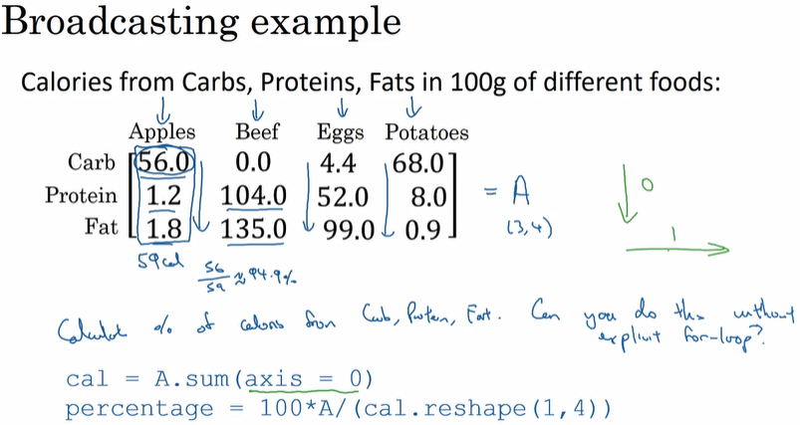

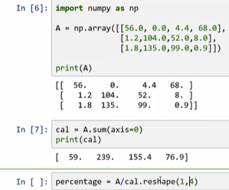

Taking 3*4 matrix and summing to a 1*4 v

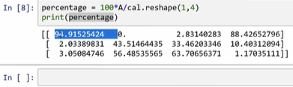

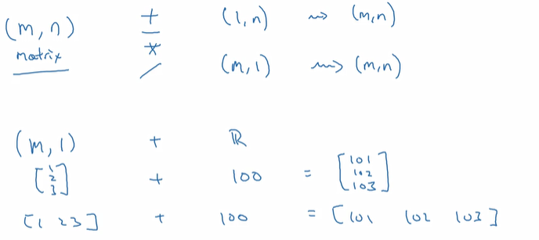

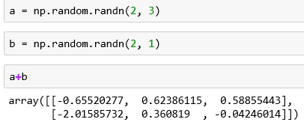

ex

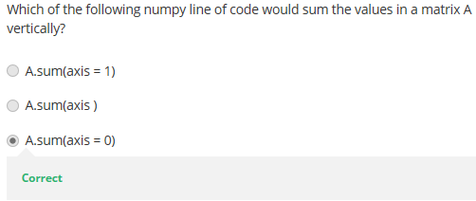

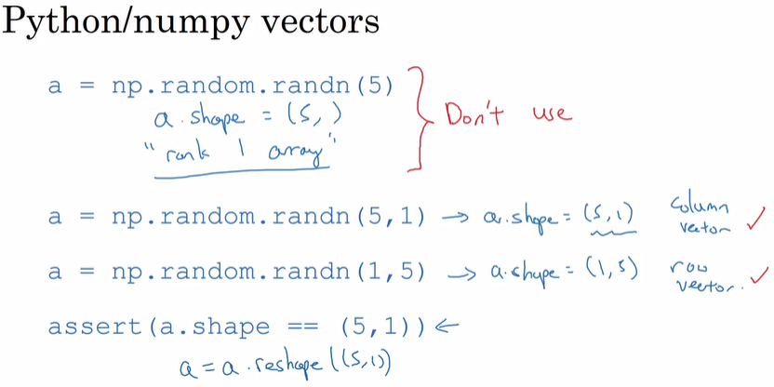

### Column vector

* column=1
* Shape(5,1) for ex
* 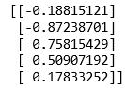

### Row vector

* Row vector is a 1xm matrix, consisting of a single row of m elements
* Row=1
* Shape(1,5) for ex
* 

So when you need a vector, I would say either use this or this, but not a rank 1 array; it is useless for transpose and dot functions as seen below

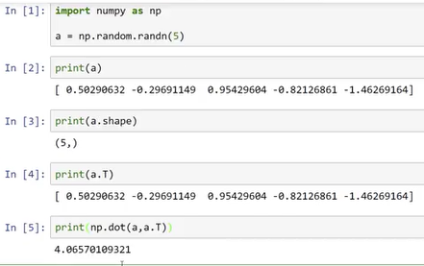

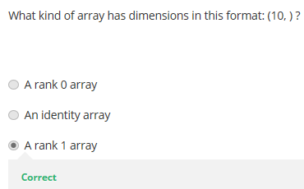

### Reshape

Converting a 3D matrix to a vector, or 2d matrix

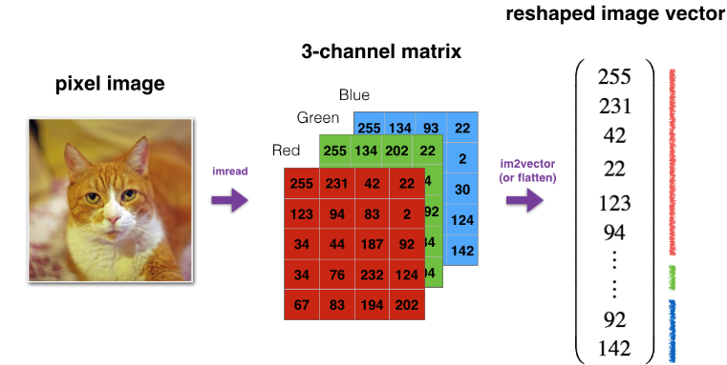

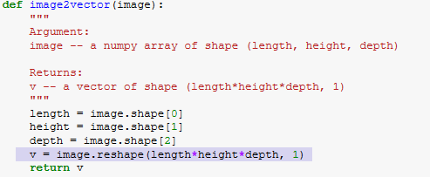

if you would like to reshape an array v of shape (a, b, c) into a vector of shape (a*b,c)

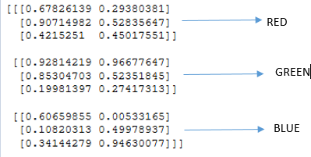

3x3x2 : the first red one is RGB values

Yellow one is x and y

### Normalizing rows

It often leads to a better performance because gradient descent converges faster after normalization

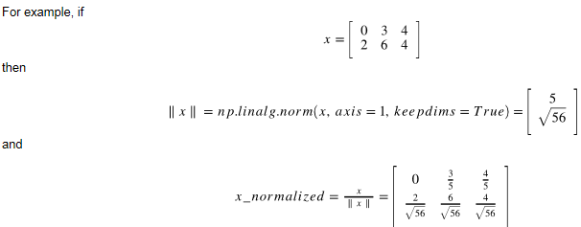

### Broadcasting and Softmax

* Broadcasting is very useful for performing mathematical operations between arrays of different shapes
* Softmax is a normalizing function used when your algorithm needs to classify two or more classes.



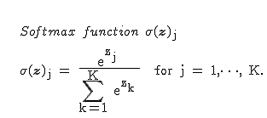

The softmax function is used in the activation function of the neural network. Normalizes between 0 and 1

|  |  |  |  |
| --- | --- | --- | --- |
|  | vector | E^x1.. | softmax |
| x1 | 0 | 1 | 0.034671 |
| x2 | -1 | 0.367879 | 0.012755 |
| x3 | 2 | 7.389056 | 0.256187 |
| x4 | 3 | 20.08554 | 0.696387 |
|  | total | 28.84247 | 1 |

### Numpy matrix operations

#### Dot

* dot = np.dot(x1,x2) -> 278
* **np.dot(a, b)" performs a matrix multiplication on a and b,**

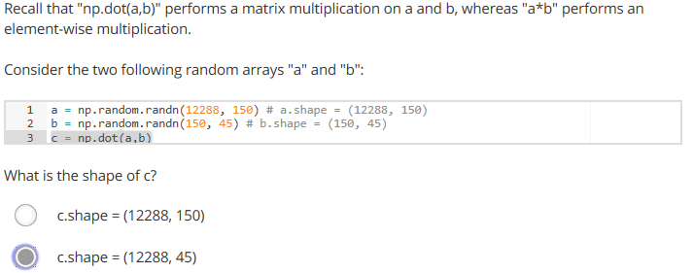

#### outer

* outer = np.outer(x1,x2) -> cartesian multiplication
* mul = np.multiply(x1,x2)-> elementwise multiplication [81 4 10 0 0 63 10 0 0 0 81 4 25 0 0]
* x1*x2 is same with multiply

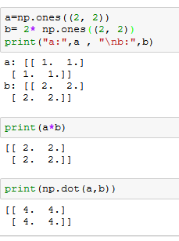

**Ex2**

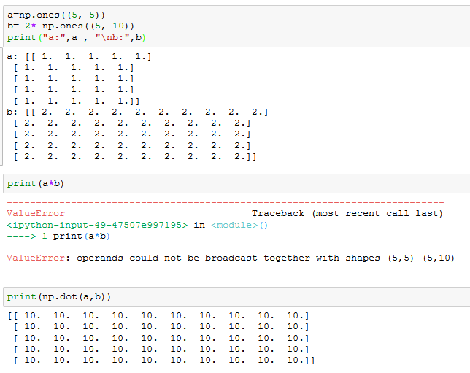

### L1, L2 Loss Functions

* L1: Least Absolute Deviations; it is used to minimize the error (sum of all absolute differences between the true value and predicted value.
* 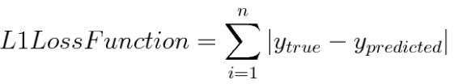
* Loss1 = np.sum(abs(y-yhat))
* L2: Loss Function is used to minimize the error which is the sum of the all the squared differences between the true value and the predicted value.
* Loss2 = np.sum(np.power((y-yhat),2))
* 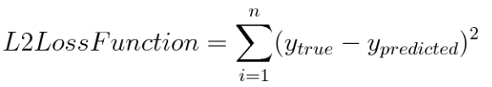

• The loss is used to evaluate the performance of your model. The bigger your loss is, the more different your predictions h(y) are from the true values (y).

* Generally, L2 Loss Function is preferred in most of the cases.

# W3

## NN Overview

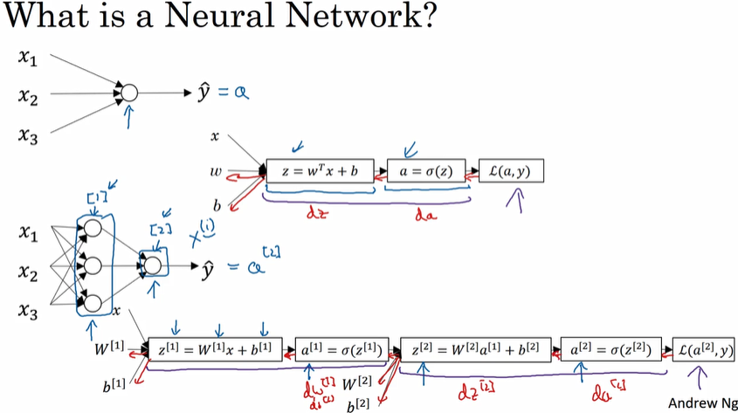

A2 is final output

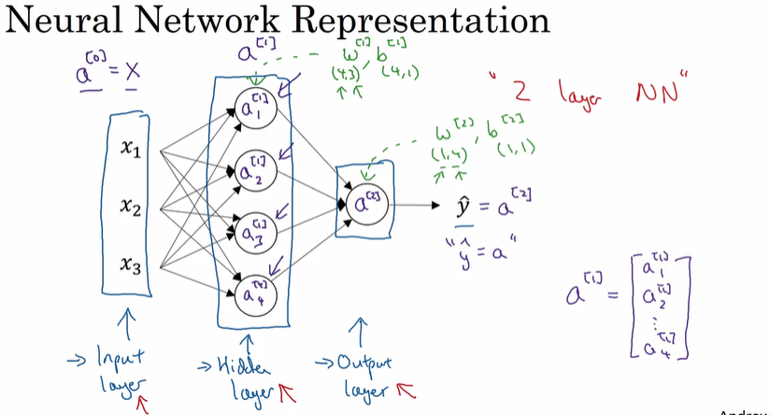

* So the term hidden layer refers to the fact t that in the training set, the true values for this nodes in the middle are not observed.
* That is you don't see what they should be in the training set. You see what the inputs are. You see what the output should be.
* This is a 2 layer NN, not counting the hidden layer

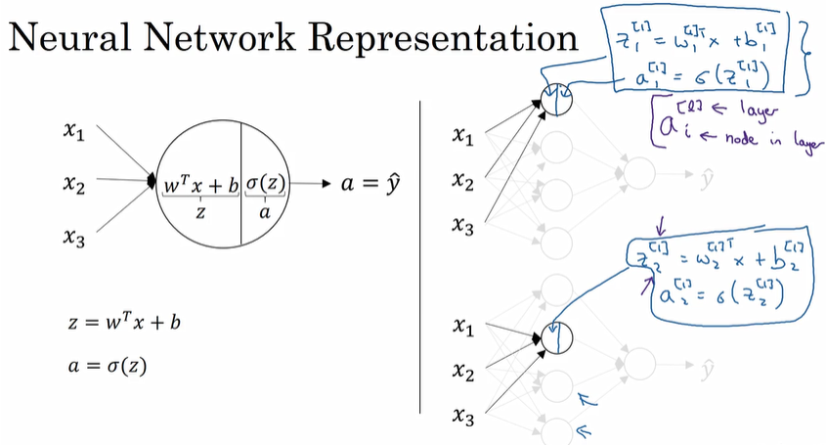

* W matrix is composed of weights controlling function mapping from layer 1 to layer 2
* To compute the first hidden node,
  + First compute z11 then a11 (sigmoid of z11)

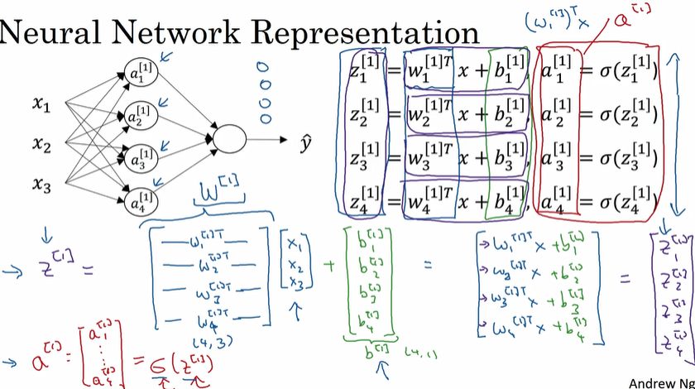

## W Matrix

* W Matrix is [4, 3]
  + in each x there are 4 weights so the first attribute 4
  + for x1 to x3 is the second attribute is 3;



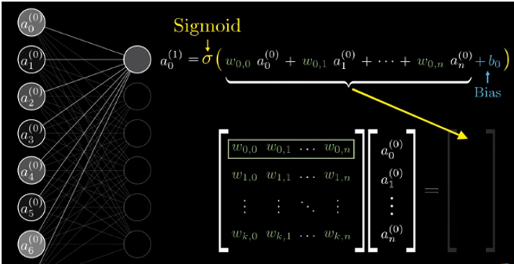

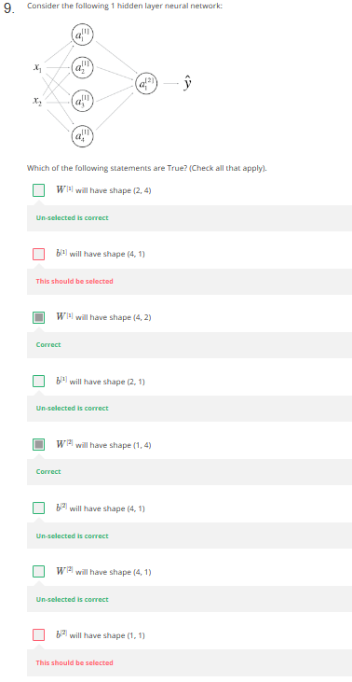

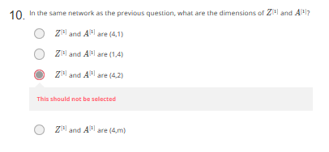

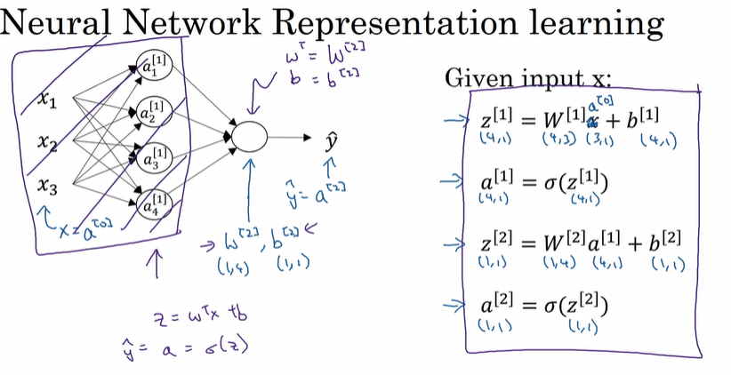

## Vectorization across multiple examples

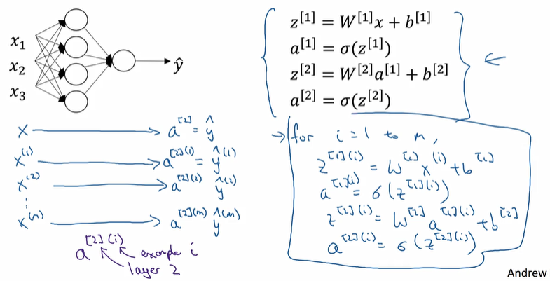

## Layer and example

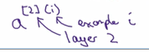



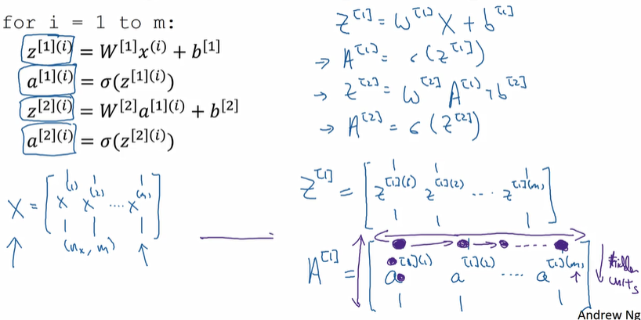

A matrix is m columns(horizontally) indicating the m different training examples.

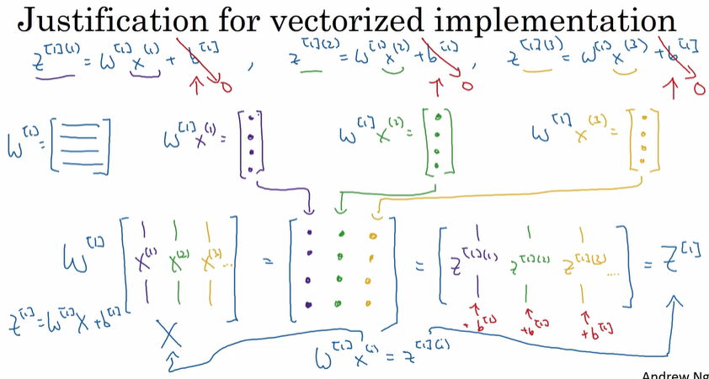

X is a matrix in which each column is one training example

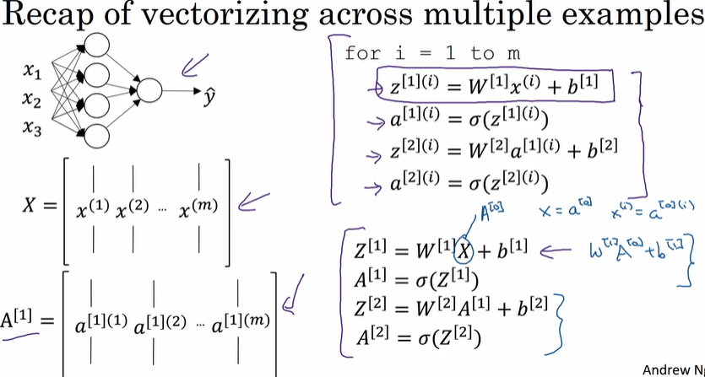

## Activation Functions

* <https://medium.com/the-theory-of-everything/understanding-activation-functions-in-neural-networks-9491262884e0>
* Neuron calculates a “weighted sum” of its input, adds a bias and then decides whether it should be “fired” or not.
* 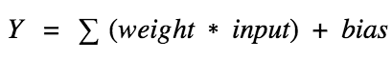
* Now, the value of Y can be anything ranging from -inf to +inf. The neuron really doesn’t know the bounds of the value. So how do we decide whether the neuron should fire or not?
  + **Activation function is used to check that neuron as fired or not. (activated or not)**
  + Activation function A = “activated” if Y > threshold else not
  + Alternatively, A = 1 if y> threshold, 0 otherwise

### Linear regression

* + A = cx, derivative with respect to x is c. That means, the gradient has no relationship with X. It is a constant gradient and the descent is going to be on constant gradient. If there is an error in prediction, the changes made by back propagation is constant and not depending on the change in input delta(x)
  + No matter how many layers we have, if all are linear in nature, the final activation function of last layer is nothing but just a linear function of the input of first layer!

### Sigmoid (Logistic Regression)

* the output of the activation function is always going to be in range (0,1)
* sigmoid is still very popular in classification problems.
* 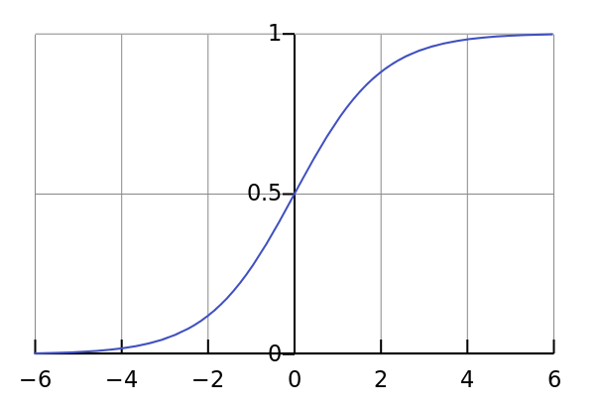 -> sigmoid
* 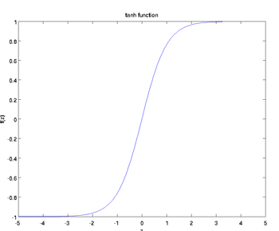-> tanh

Tanh is faster, going from a=0 to 1 in 2z, while sigmoid goes in 4z’s.

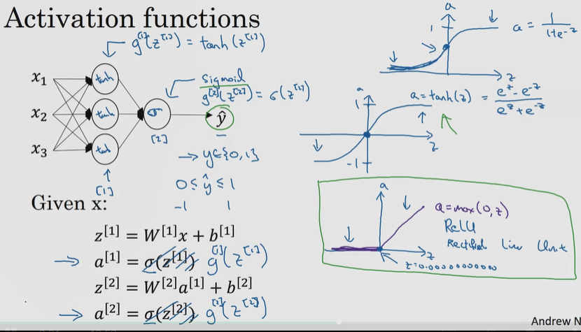

### Tanh

Hyperbolic tangent function

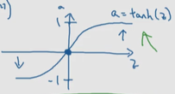 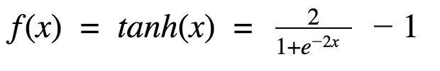

* 
* It is a scaled sigmoid function
* goes between plus 1 and minus 1
* Has the effect of centering your data so that the mean of the data is close to the zero rather than maybe a 0.5 and this actually makes learning for the next layer a little bit easier
* I pretty much never use the sigmoid activation function anymore
* the tanh function is almost always strictly superior the one exception is for the output layer because if Y is either 0 or 1 then it makes sense for yhat to be a number that you want to output plus between 0 and 1 rather than between minus 1 and 1 so the one exception where I would use the sigmoid activation function is when you're using binary classification in which case you might use the sigmoid activation function for the output layer
* so Z is very large or Z is very small the slope of the function you know ends up being close to zero and so this can slow down gradient descent

### RelU function

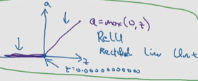

* Another point that I would like to discuss here is the sparsity of the activation. Imagine a big neural network with a lot of neurons. Using a sigmoid or tanh will cause almost all neurons to fire in an analog way ( remember? ). That means almost all activations will be processed to describe the output of a network. In other words the activation is dense. This is costly. We would ideally want a few neurons in the network to not activate and thereby making the activations sparse and efficient.
* ReLu give us this benefit. Imagine a network with random initialized weights ( or normalised ) and almost 50% of the network yields 0 activation because of the characteristic of ReLu (
* rectified linear unit
* the derivative is 1 so long as Z is positive
* derivative or the slope is 0 when Z is negative
* the advantage of both the value and only key value is that for a lot of the space of Z the derivative of the activation function the slope of the activation function is very different from zero and so in practice using the regular activation function
* your new network will often learn much faster than using the tangent or the sigmoid activation function
* and the main reason is that on this less of this effect of the slope of the function going to zero which slows down learning and
* I know that for half of the range of Z the slope of RelU is zero but in practice enough of your hidden units will have Z greater than zero so learning can still be quite mask for most training examples so let's just quickly

### Pros and cons

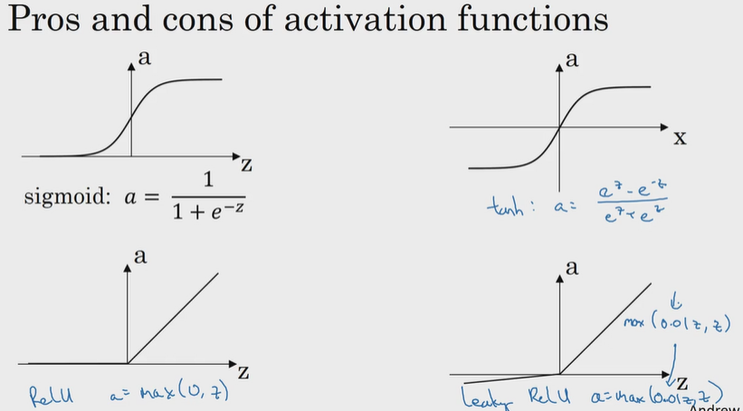

Sigmoid: never use this except for the output layer if you are doing binary classification

Tanh: superior to sigmoid

RelU : if you don’t know what to use, use this

## Why do u need nonlinear activation functions?

Instead of a1=g1*z1 -> if we use a1=z1 this will be linear activation :

* if you were to use linear activation functions or we go to call them identity activation functions then the new network is just outputting a linear function of the input
* if you don't have an activation function then no matter how many layers your neural network has always doing is just computing a linear activation function so you might as well not have any hidden layers
* this can be used only if Y is a real number such as housing prices

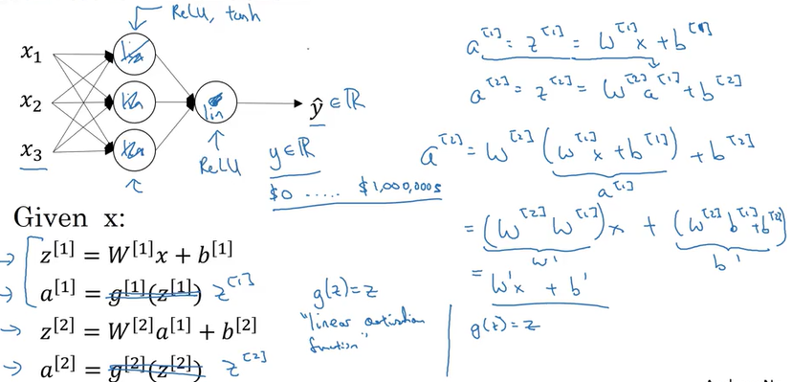

## Derivatives of activation functions

* when you implement back-propagation for your neural network you need to really compute the slope or the derivative of the activation functions

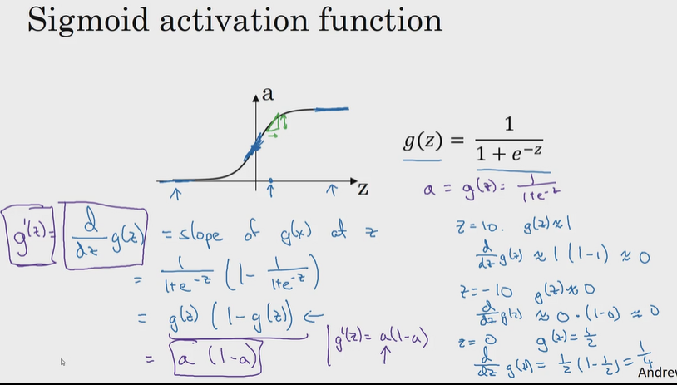

If a Is computed, you can easily calculate slope(derivative). a*(1-a)

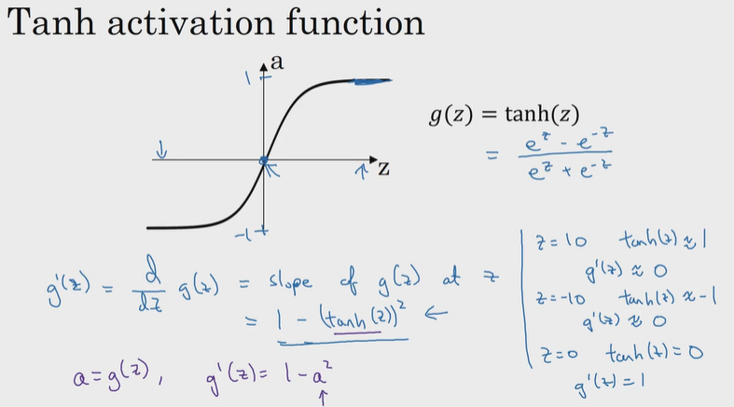

1-a2

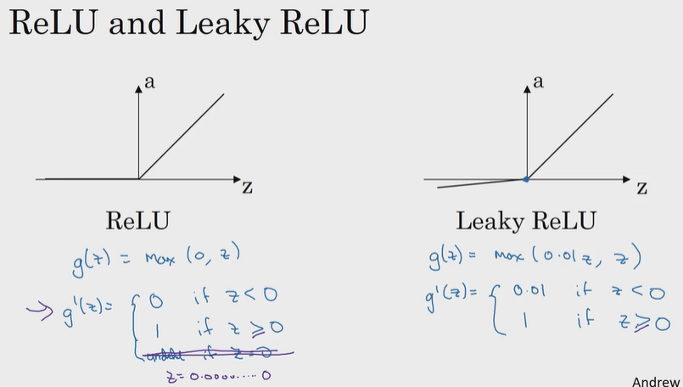

## GD for NN

With one hidden layer

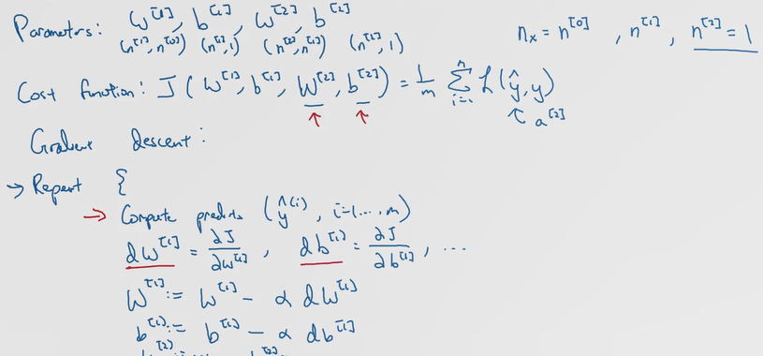

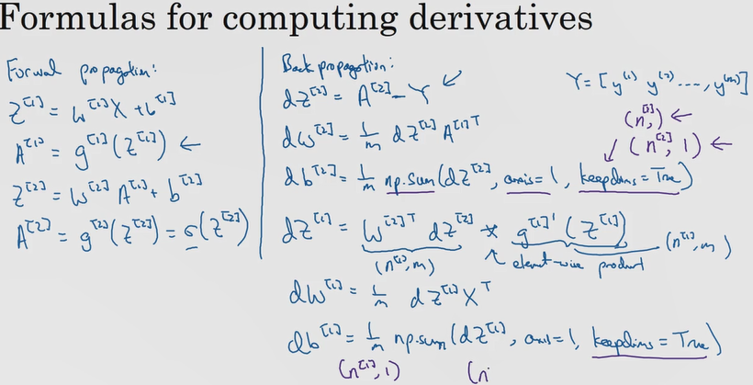

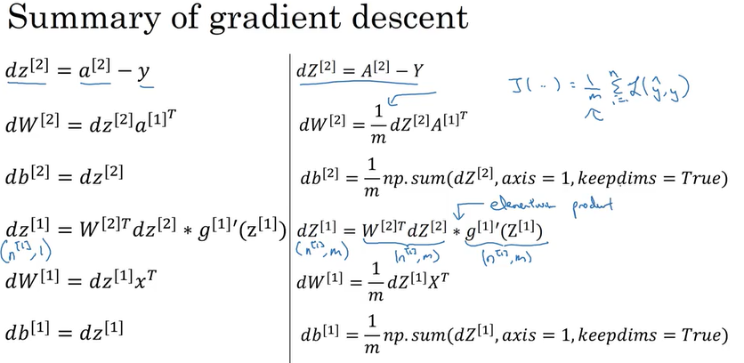

## Random Initialization

* For logistic regression , it was OK to init the weights to zero
* But it won’t work for NN to init all weights to zero
* Let‘s see why it doesn’t work for GD

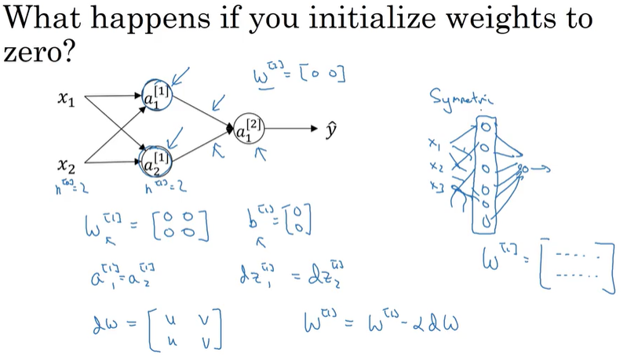

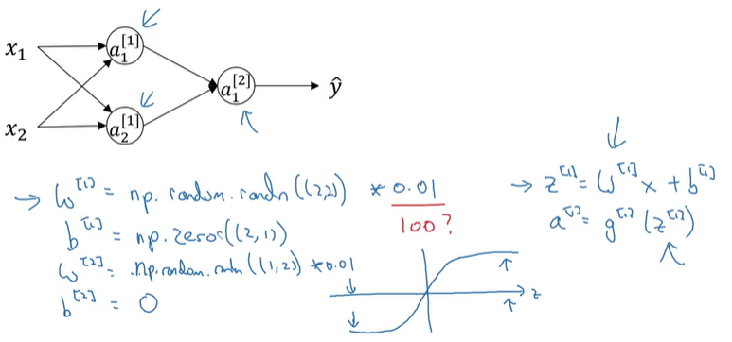

* So if w is very big, z will be very, or at least some values of z will be either very large or very small.
* And so in that case, you're more likely to end up at these fat parts of the tanh function or the sigmoid function, where the slope or the gradient is very small.
* Meaning that gradient descent will be very slow
* When you're training a neural network with just one hidden layer, it is a relatively shallow neural network, without too many hidden layers. Set it to 0.01 will probably work okay

# W4

## Deep L-layer NN

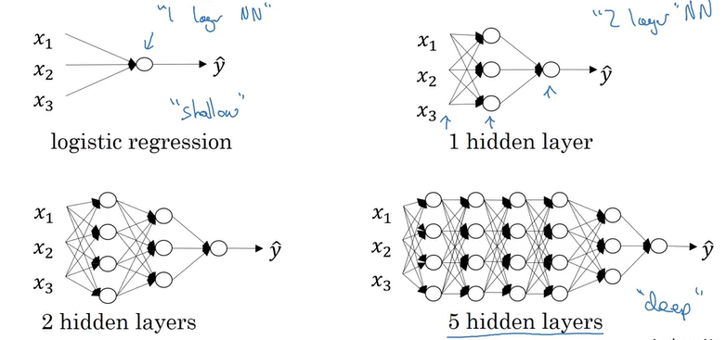

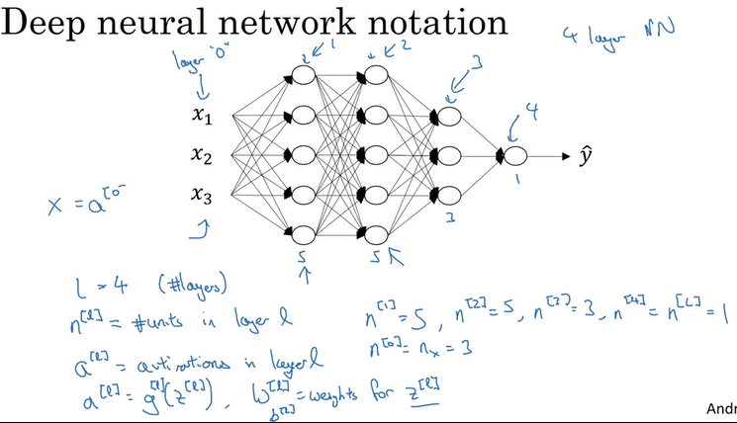

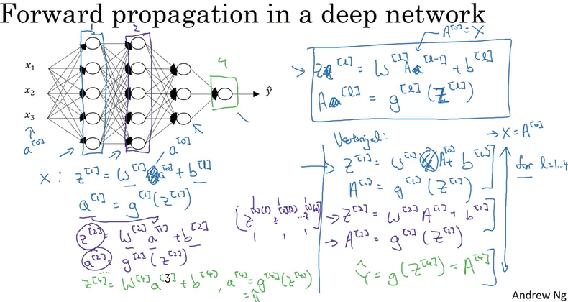

## Getting matrix dims right

### W and b

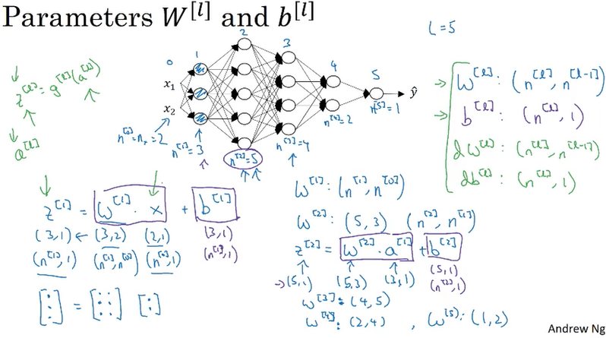

* Capital L is equal to 5, not counting the input layer, there are five layers here, so four hidden layers and one output layer.
* n is the number of hidden units
* z is the vector of activations for this first hidden layer z1 -> 3x1
* general formula of a matrix

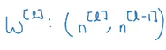

* b vector is to be the same of W x A matrix

### Vectorized Implementation

* capitalized Z means all training set, whereas z is one example;
* Taking all m training set, instead of one example
* Z matrix becomes n,m dimensional; all your training examples stacked horizontally. So it's now n 0 by m

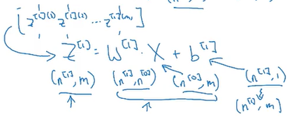

* b1 is still n1 by 1, but when you take w1*x and add it to b, then through Python broadcasting, this will get duplicated and turn n1 by m matrix, and then add the element wise.
* 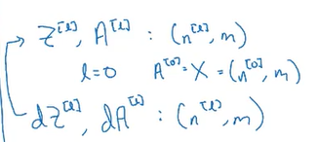

## Why deep representations?

### Image recognition

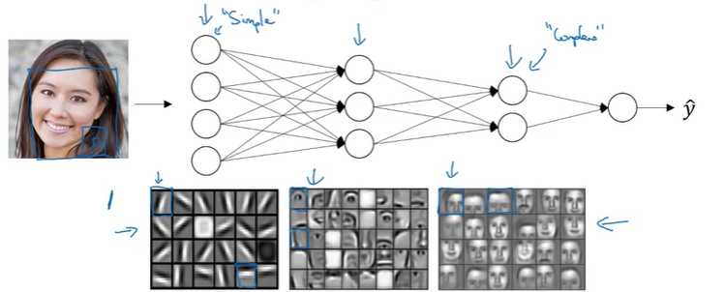

* Let's think about where the edges in this picture by grouping together pixels to form edges. It can then de-detect the edges and group edges together to form parts of faces.
* The earlier layers of the neural network detects simple functions, like edges. And then composing them together in the later layers of a neural network so that it can learn more and more complex functions.
* The edge detectors are looking in relatively small areas of an image, maybe very small regions like that. And then the facial detectors you can look at maybe much larger areas of image

### Sound recognition



* In the word cat, the C is a phoneme, the A is a phoneme, the T is another phoneme. But learns to find maybe the basic units of sound and then composing that together maybe learn to recognize words in the audio. And then maybe compose those together, in order to recognize entire phrases or sentences
* Deep Internet work with multiple hidden layers might be able to have the earlier layers learn these lower level simple features and then have the later deeper layers then put together the simpler things it's detected in order to detect more complex things like recognize specific words or even phrases or sentences. The uttering in order to carry out speech recognition

## Circuit Theory

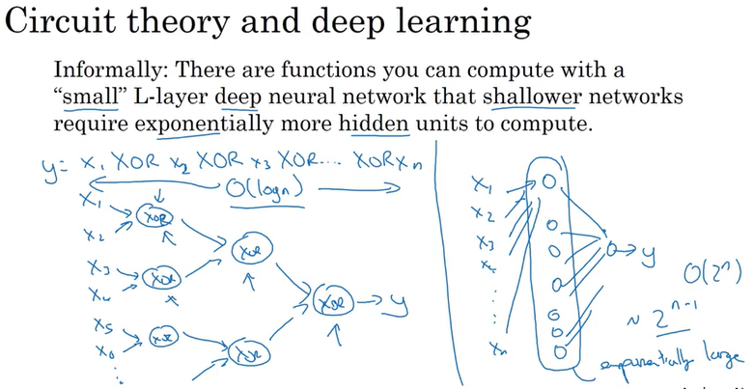

* if you're forced to compute this function with just one hidden layer, so you have all these things going into, so the hidden units. And then these things then output Y.
* Then in order to compute this XOR function, this hidden layer will need to be exponentially large, because essentially, you need to exhaustively enumerate our 2 to the N possible configurations
* circuit theory less useful for gaining intuitions,

## Building blocks of deep NN

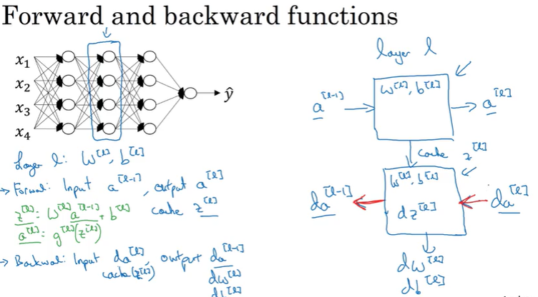

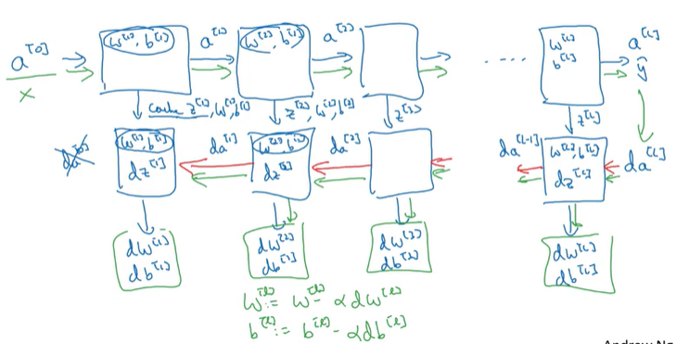

* cache deposit information from one to the other

## Fwd prop for layer l

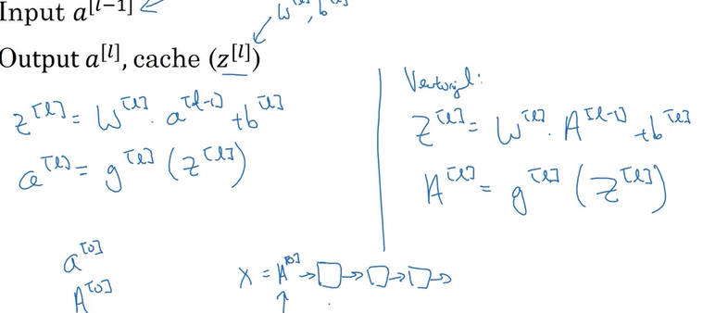

## Bckwrd for Layer l

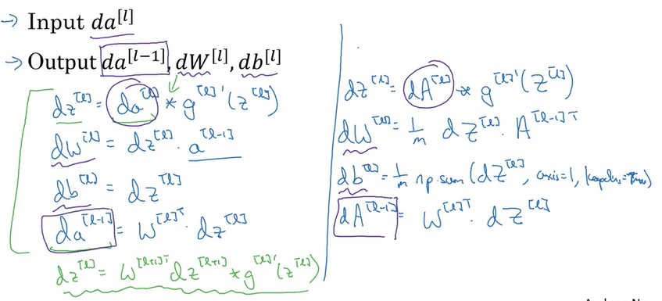

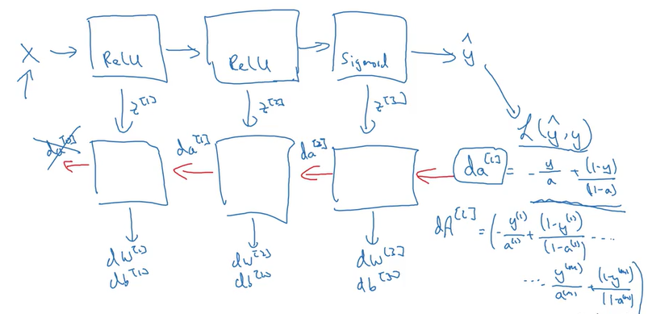

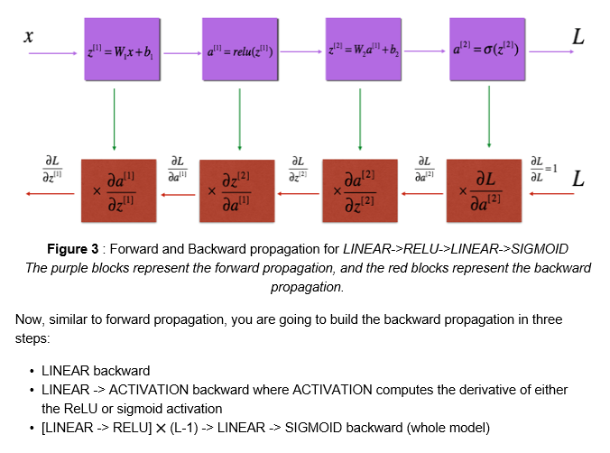

### Hyper parameters

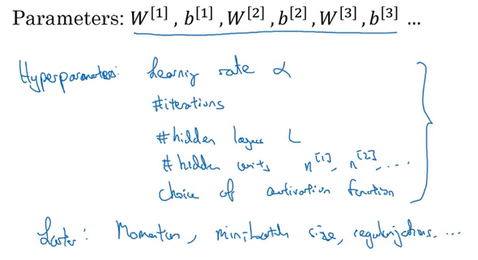

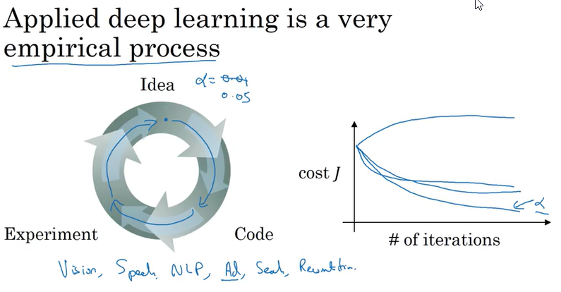

# Programming Assignments

